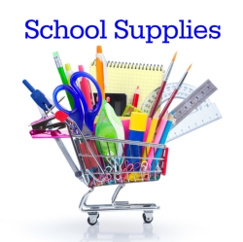 **Winterset Elementary**

**2023-2024 Supply List**

**Second Grade**

**Please write your child’s name on the following supplies:**

1 pair scissors

1 zippered pouch for special pencils and scissors

2 wide-ruled composition notebooks (no spiral-bound, please)

1 water bottle that closes securely

Backpack

**You do not need to write your child’s name**

**on the following supplies:**

2 dozen Ticonderoga pencils

1 box colored pencils

4 24-pack Crayola crayons

1 box Crayola markers

4-6 small glue sticks

1 PURPLE plastic pocket folder (I have labels)

1 GREEN plastic pocket folder (I have labels)

1 pair of headphones (I have labeled bags)

2 boxes of Kleenex

1 container Clorox wipes

1 package baby wipes

1 box of quart size Ziplock bags (girls)

1 box of gallon size Ziplock bags (boys)

**Please do not send in pencil sharpeners, mechanical pencils, binders, or pens**